W1 PRACTICE
PART 3 – MANIPULATION

 Before this practice
- You need to have completed: PART 1- EXPLORATION

 Learning objectives
- Apply type inference for variable declarations.
- Handle nullable and non-nullable variables.
- Differentiate between final and const.
- Manipulate strings, lists, and maps.
- Use loops and conditions to control flow.
- Define and call functions with positional and named arguments, understand arrow syntax



 Are you lost?
Read the following documentation to be ready for this practice:

- Variables
- Null Safety
- Built-in types
- Lists
- Loops
- Conditions
- Functions

EX 1 – Manipulate Types
Are you clear about strings, integer, list, map, set, objects in Dart?
Examine the given data structures and write the inferred Dart type for each one (see example)

Notes
- First find by yourself the type
- If you need, double check your answer with VSCode.

Data | Dart Type
const studentGrades = {  'Sokan': [90, 85, 88],  'Sokea': [70, 80, 75],  'Hay': [95, 92, 89],  }; | Map<String, List<int>>
const pizzaPrices = {  'margherita': 5.5,  'pepperoni': 7.5,  'vegetarian': 6.5,  }; | Map<String, double>
const books = [  {'title': '1984', 'author': 'George Orwell'},  {'title': 'Brave New World', 'author': 'Aldous Huxley'},  {'title': 'Fahrenheit 451', 'author': 'Ray Bradbury'},  ]; | List<Map<String, String>>
const company = {  'HR': {'employees': 5, 'budget': 20000},  'IT': {'employees': 10, 'budget': 50000},  'Marketing': {'employees': 7, 'budget': 30000},  }; | Map<String, Map<String, int>>
const coordinates = [  [1, 2],  [3, 4],  [5, 6],  ]; | List<List<int>>
const productDetails = {  'id': 101,  'name': 'Laptop',  'price': 999.99,  'inStock': true,  }; | Map<String, var>
const operations = [  (int a, int b) => a + b,  (int a, int b) => a - b,  (int a, int b) => a * b,  ]; | List<arrow function>
const distances = {3.1, 5.5, 10.2, 7.8}; | Set<double>
const university = {  'departments': [  {  'name': 'Computer Science',  'students': [  {'name': 'Alice', 'age': 22},  {'name': 'Bob', 'age': 24},  ]  },  {  'name': 'Mathematics',  'students': [  {'name': 'Charlie', 'age': 21},  {'name': 'Dave', 'age': 23},  ]  }  ]  }; | Map<String,List<Map<String,List<Map<String, var>>>>>

EX 2 – Manipulate final and const
In this exercise, you need to decide which variable can be declared as const or final.

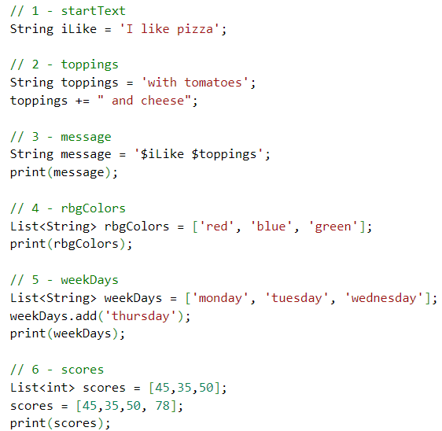

Guess which variables can be declared as const, final or var, and explain your choices.
Notes
- Read here to understand the concepts.
- Prefer const over final over var.

 | VAR, FINAL, CONST? | WHY
iLike | CONST | Because this variable never changes
toppings | Var | 2 type of string become one
message | Final | Variable declare only one
rbgColors | Const | This variable never change
weekDays | Var | This variable is change more than once
score | Var | This variable is chagne more than once

